Virtual Science Lab

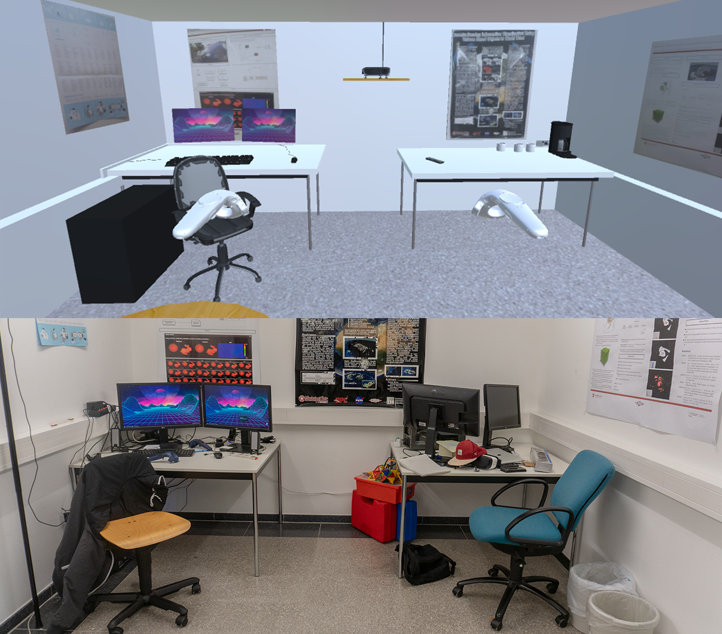

Figure 1 Rebuild of a real laboratory (bottom) in a Virtual Reality laboratory (top). If you stand in the real laboratory and put on the VR glasses, you’ll stand in a virtual copy of this room on the same startpoint.

*Abstract* **— The Virtual Science Lab is presented below. It is a virtual reality application that is intended to intuitively illustrate and explain experiments from various branches of science to the user. Unity was chosen as the development environment. The application was optimized for the HTC Vive Pro. Experiments from various fields of science (e.g. mathematics, chemistry, computer science) are presented for a user to carry out. There is an assumption that through playful and native testing, the user is willing to learn about science indirectly. A look into the future shows that this assumption must be evaluated in tests and that a control system must be evaluated for a wide variety of hardware variants.**

Index Terms: *Virtual Reality; Digital Learning*

# Introduction

The basic idea behind the Virtual Science Lab is to convey science as clearly and playful as possible. The technical means of virtual reality are used. This is intended to ensure that the tests can be carried out as natively as possible, for example, by moving the hand and then accessing a button. Normal movement in the room is also possible, which is why it is assumed that the barrier of entry is significantly lower than, for example, control with mouse and keyboard or gamepad. The visual impression should also be increased through the use of virtual reality, since you can turn around and move freely in the room and so be stimulated to explore. The Virtual Science Lab will initially be developed and evaluated on HTC Vive Pro.

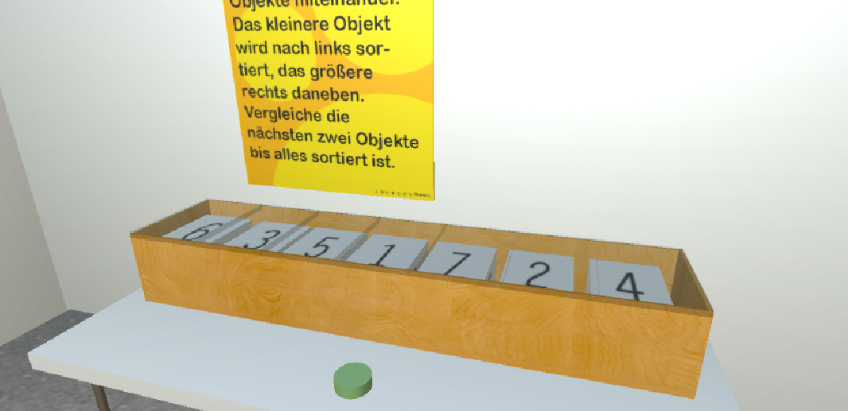

Figure 2 One example of a task. Bubble sort – a simple sorting algorithm – including an information poster on the wall behind. There are the conclusion and the task written. The user can read it at any time during the simulation.

# Related Work

Distance learning and open universities are more and more coming towards common practice. Some domains such as science and engineering are widely behind on using modern technologies for teaching and learning. As you can see in *Open MINT Labs* [3] or *PraxiLabs* [5] there are some similar projects on giving science a digital environment. Apps or software like *PraxiLabs* on desktop or mobile devices are basic concepts our work is based on. *PraxiLabs* is build as a 3D computer game like software the user has to control via touchscreen, controller or mouse and keyboard. These controls are less native as virtual/augmented reality where our project is based on.

*Open Mint Labs* sets their goals similar to our project - adding virtual parts to real laboratory experiments.

# Virtual Science Lab

The great advantage the use of virtual reality offers is that the experiments can be carried out as often as desired without exposing the test person to health or physical risks. In addition, no valuable resources are wasted, such as chemicals or laboratory equipment. The application can be used in terms of time and space, which makes it significantly more flexible compared to laboratory tests at a university, which the target group makes clear. In the school and university context, the Virtual Science Lab can be an immense relief for teachers and learners.

There is an assumption that through the playful and safe handling of laboratory equipment, a greater knowledge in the respective area accumulates with the handling. This has not been researched empirically, but is planned for the following steps.

The current status includes experiments from the fields of chemistry, physics, mathematics, electrical engineering, biology and computer science. These include an experiment in which substances can be safely held in an open bunsen burner flame and the flame then changes color, various sorting algorithms, electronic circuits with measuring devices or examinations of substances with a microscope.

There are hardly any other branches of science and opportunities for experimentation, and it can always be expanded as needed.

Every experiment has information like conclusion, given task and theory behind it included as different kinds of objects. Sometimes you got a clipboard with a letter, posters on the wall or a beamer projection. These different ways to get your information keeps the user motivated to research and interact with more and more experiments or objects.

# Discussion

The future steps primarily include a mobile build that will initially work with Android and iOS devices with virtual reality, but also with augmented reality. The advantage of this would be that it is possible for a larger group of people (e.g. lecture room with many students) to have the same experiment carried out at the same time.

The big problem with these applications is to include different devices with different control types and to look at different hardware.

In addition, a kind of empirical field test makes sense by testing whether pupils or students who complete the Virtual Science Lab could do better in a suitable test than a group that the laboratory has not seen.

The construction of the laboratory rooms more and more resembled a process in which the same steps were carried out one after the other. First the room is delimited by walls, floor and ceiling, a door is added in front of which the camera is placed so that one enters the room at the position of the door. Then, if necessary, tables are arranged, as are the various utensils necessary for the intended experiments. Finally, the functionality is added in form of scripts which are written to enable the experiment to be carried out. The test is then tested in the virtual reality laboratory and, if necessary, bugs are noted and fixed. This evaluation process is carried out iteratively any number of times until the result is satisfying. In this way, any number of laboratory rooms can be supplemented in the following, thus covering a wide range of specialist areas with different experiments that have not yet been included (e.g. geography).

# Conclusion

This project shows that the Virtual Science Lab can offer an opportunity to improve school and university teaching. Many scientific experiments are already safe and playable and marked with explanations and instructions.

A look into the future shows which changes need to be addressed and how to continue with the laboratory. On the one hand, a build is required that can be executed and controlled on any hardware. The focus should be on cheap alternatives for mobile devices, so that a larger group of pupils or students can work on experiments at the same time.

In addition, evaluations must be carried out to determine how far a student's knowledge is gained by completing the tests in virtual reality.

# References

1. B. Sun, U. Chikwem and D. Nyingifa, "VRLearner: A Virtual Reality Based Assessment Tool in Higher Education," 2019 IEEE Conference on Virtual Reality and 3D User Interfaces (VR), Osaka, Japan, 2019, pp. 1640-1645.
2. G. Zhang, "Virtual Simulation for History Education," 2019 IEEE Conference on Virtual Reality and 3D User Interfaces (VR), Osaka, Japan, 2019, pp. 1646-1651.
3. Fleuren, Daniela: „Open MINT Labs : Mit virtuellen Laboren zu höherem Lernerfolg“ - In: Aßmann, Sandra; Bettinger, Patrick; Bücker, Diana; Hofhues, Sandra; Lucke, Ulrike; Schiefner-Rohs, Mandy; Schramm, Christin; Schumann, Marlen; van Treeck, Timo [Hrsg.]: Lern- und Bildungsprozesse gestalten. Junges Forum Medien und Hochschulentwicklung (JFMH13). Münster ; New York : Waxmann 2016, S. 141-150.
4. V. Potkonjak, M. Gardner, V. Callaghan, P. Mattila, C. Guetl, V. Petrović, K. Jovanović: „Virtual laboratories for education in science, technology, and engineering: A review“ – In*: Computers & Education*, Elsevier, 2016.
5. N.N.: *PraxiLabs*, in: Website PraxiLabs, URL: https://praxilabs.com/, last seen 06.01.2020